Module 5.2 Assignment
Group A
Kobe Alexander, Oscar Avina, Maddison Montijo,
Jordyn Rylander, Garrett Woods
4/19/2026
Bellevue University
CSD 325

Overall Program Flowchart
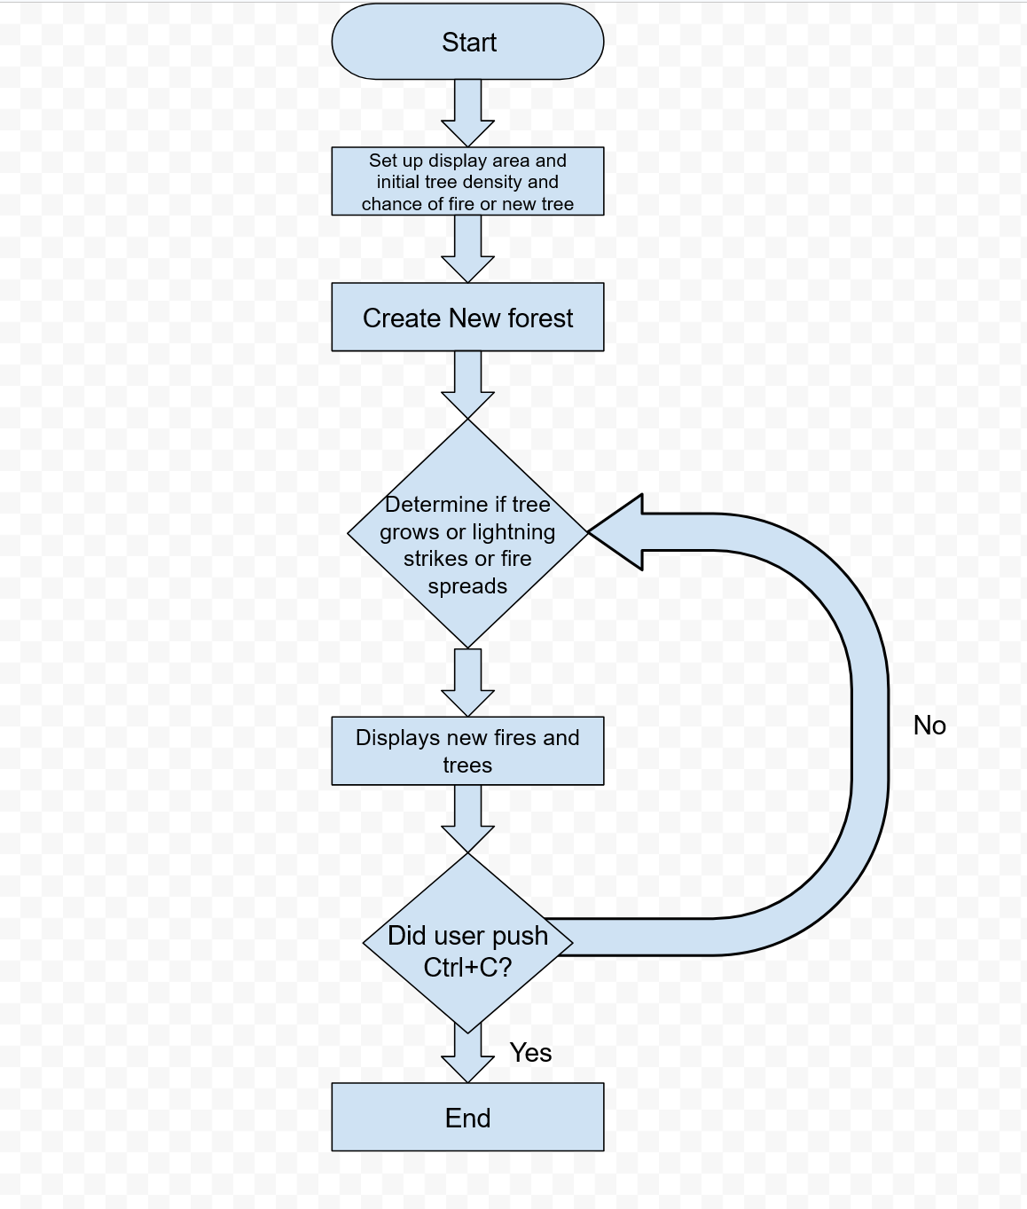

createNewForest Function

